Deaths in Game of Thrones

| Pedro Elias  89519 | Raquel Santos  89533 | Tiago Afonso  89436 |
| --- | --- | --- |

# ABSTRACT

This report describes the project develop for the Information Visualization course at Instituto Superior Técnico. The project consists of a visualization about the deaths of the *Game of Thrones* TV show and their relation with the book collection *A Song of Ice and Fire*. It is developed using HTML, CSS, JS and d3.js.

The visualization allows to analyze all the deaths along the different episodes and analyze the different conditions where they occur such as killing method, allegiance of the involved or location of the death.

Abstracts should be about 150 words and are required.

## Author Keywords

Information Visualization; InfoVis; Game of Thrones; A Song of Ice and Fire; Deaths; Kills.

## ACM Classification Keywords

H.5.m. Information interfaces and presentation (e.g., HCI): Miscellaneous; See<http://acm.org/about/class/1998> for the full list of ACM classifiers. This section is required.

Human-centered computing: Visualization: Visualization application domains: Information visualization

# INTRODUCTION

The domain tackled are the deaths in the TV show Game of Thrones that occurred on-screen. Game of Thrones is one of the most famous shows of all time, and it is well known for frequently killing characters, either being part of the main cast, or background characters.

The popularity of the show makes it an interesting subject for data analysis and the creation of visualizations which allow the user to extract more information from each death.

Some questions that could be answered with visualizations regarding this problem domain are:

* How was the evolution of the number of kills for each character through the seasons?
* How was the evolution of the killing method for each character through the seasons?
* Which houses suffered the most casualties / have the most conflicts between each other?
* Which episode and season has the most deaths?
* Which houses have the most conflicts between each other?
* Where did most kills take place?
* Which species had the most deaths?
* Which gender has the most kills and deaths?
* There is a preferred killing method according to the killer’s house?
* Is the location of the deaths a factor when choosing the killing method?
* What percentage of TV show deaths were based on the books?
* Did the deaths in the TV show and the books occur by the same chronological order?

Currently there are no known tools to automatically collect and process data for deaths of characters in a TV Show. All the data needs to be imputed and verified manually.

Recording and analyzing the deaths in a TV Show whilst comparing them to the events of the original work (the book) not only allows for a better understanding of the evolution of characters, their locations throughout time, the interactions they had with other characters, but also the impact of battles or other important events on characters and houses.

Comparing the deaths in the TV show and in the book also helps seeing how much of the show was adapted from the books and where it diverges. Some characters only exist in the show, others only exist in the book, so it is interesting to analyze the difference in their fates.

# Related Work

There are many analysis on Game of Thrones available online, due to the popularity of the books and the show. While all focus on the Game of Thrones domain, some use completely different data (for example, the conversations between characters in the book), or try to answer different questions:

* Interactive visualization of Game of Throne deaths [1]. It uses the same initial dataset we used to analyze the show deaths. However, the visualization is very static and is too focused on a single character at a time, which does not allow the user to answer all the previous questions. Some idioms have scalability issues and the filters are insufficient for our needs.
* Narrative chart [2]. The domain of this visualization is the interactions between characters in the TV show and their locations throughout time. It also provides information on screen time. The interactions focused by the visualization were not used in our dataset since we mainly focus on deaths.
* The Chaos Ladder [3]. It focuses on characters and their number of appearances in the TV show. While it also shows their life status, it does not have any additional information on what happened in each death, so it does not answer our questions.
* Narrative structure of A Song of Ice and Fire [4] creates a fictional world with realistic measures of social complexity. This research paper thoroughly analyses the narrative and interactions between characters to measure the complexity of the fictional world with our own. Since we are mostly interested in the deaths and comparison between show and book, it does not answer our questions.
* Illustrated Game of Thrones Deaths [5] uses a similar dataset to analyse each death in the TV show. Even though it uses idioms such as a map and dot plots, it lacks the filters needed to answer our questions and its purpose is to guide the user to a predetermined analysis, lacking interactivity.

# The data

The data was obtained from two different datasets being the first one about the deaths in the TV show [1] and the second one referring to the deaths that occurred in the book collection [2].

Initially, we kept all the data from the first dataset and joined the columns of the second with an outer merge. Then, we removed some lines to keep only the characters that have died in the TV show and appeared in the first dataset.

We removed the repeated columns and introduced two derived measures to analyze if the character appeared in the books and to differentiate the deaths of the animals.

As part of the cleaning process, we removed repeated characters that appeared with different names, corrected wrong values and introduced the missing values based on research on some wikis dedicated to Game of Thrones [4] and A Song of Ice and Fire [5]. Also, it was added sentinel values for the missing values that did not apply.

During the implementation, some changes were made to adjust the data to the problems that start appearing and that were not predicted at first.

Considering that we are treating the killer and the killed characters in the same way, we introduced columns with the characteristics of the killer. All this information was manually introduced based on our knowledge from the TV show and the previously mentioned wikis.

Additionally, we transformed the columns related to the death in the book into the estimated death, converting the chapters into episodes according to the narrative [3].

To simplify the representation of the deaths of the animals, we introduced the allegiance “Animal” and changed this value for all.

To keep the legibility of the chord diagram, considering that we had 278 characters, we had to introduce two new columns with the names that would be represented. The characters with higher number of kills are represented by their name and the remaining are aggregated by their allegiance.

To represent the points in the map, it was introduced two columns with the coordinates of each location. These coordinates were estimated considering the annotated maps that we found online.

Finally, we removed the columns related to the introduction of the character in the book and the death year considering that it didn’t follow the theme of the visualization. Also, we ended up deleting the two derived measures initially introduced, considering that we could represent the same data without them after the modifications.

What data did you think you’d get and ended up not finding? Which compromises did you make? Also, be sure to mention scalability issues. Did you have to filter things out? Aggregate them?

# Visualization

A

## Overall Description

A

## Rationale

A

## Demonstrate the Potential

A

# Implementation details

A

# conclusion & future work

A

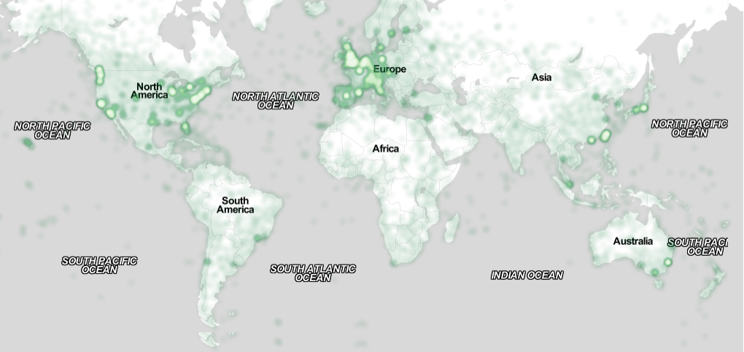

Figure 2. Sample of a wide figure. Be sure to place at the top or bottom of the page. Ensure that important information is legible in both black-and-white and color printing. Image: CC-BY-ND ayman on Flickr.

## Table Style

The text of tables will format better if you use the Table Text style (as in Table 1). If you do not use this style, then you may want to adjust the vertical spacing of the text in the tables. To adjust the spacing of text in a table in Word, use Home | Paragraph | Indents and Spacing. Generally, text in each field of a table will look better if it has equal amounts of spacing above and below it, as in Table 1. Table captions should be placed below the table. We recommend table lines be 1 point, 25% black. Minimize use of unnecessary table lines.

Write in a straightforward style.

* Try to avoid long or complex sentence structures.
* Use common and basic vocabulary (e.g., use the word “unusual” rather than the word “arcane”).
* Briefly define or explain all technical terms that may be unfamiliar to readers.
* Explain all acronyms the first time they are used in your text—e.g., “Digital Signal Processing (DSP)”.
* Explain local references (e.g., not everyone knows all city names in a particular country).
* Explain “insider” comments. Ensure that your whole audience understands any reference whose meaning you do not describe (e.g., do not assume that everyone has used an Android phone, or a particular application).
* Explain colloquial language and puns. Understanding phrases like “red herring” may require a local knowledge of English. Humor and irony are difficult to translate.
* Use unambiguous forms for culturally localized concepts, such as times, dates, currencies, and numbers (e.g., “1-5- 97” or “5/1/97” may mean 5 January or 1 May, and “seven o’clock” may mean 7:00 am or 19:00). For currencies, indicate equivalences: “Participants were paid ₩22, or roughly US$29.”
* Be careful with the use of gender-specific pronouns (*he*, *she*) and other gendered words (*chairman*, *manpower*, *man-months*). Use inclusive language that is gender-neutral (e.g., *she* *or* *he*, *they*, *s/he*, *chair*, *staff*, *staff-hours*, *person-years*). See the *Guidelines for Bias-Free Writing* for further advice and examples regarding gender and other personal attributes [9]. Be particularly aware of considerations around writing about people with disabilities.
* If possible, use the full (extended) alphabetic character set for names of persons, institutions, and places (e.g., Grønbæk, Lafreniére, Sánchez, Nguyễn, Universität, Weißenbach, Züllighoven, Århus, etc.). These characters are already included in most versions and variants of Times, Helvetica, and Arial fonts.

# Accessibility

The Executive Council of SIGCHI has committed to making SIGCHI conferences more inclusive for researchers, practitioners, and educators with disabilities. As a part of this goal, the all authors are asked to work on improving the accessibility of their submissions. Specifically, we encourage authors to carry out the following five steps:

1. Add alternative text to all figures
2. Mark table headings
3. Generate a tagged PDF
4. Verify the default language
5. Set the tab order to “Use Document Structure”

For more information and links to instructions and resources, please see: <http://chi2016.acm.org/accessibility>.

# Page Numbering, Headers, and Footers

Your final submission should not contain footer or header information at the top or bottom of each page. Specifically, your final submission should not include page numbers. Initial submissions may include page numbers, but these *must* be removed for camera-ready. Page numbers will be added to the PDF when the proceedings are assembled.

On pages beyond the first, start at the top of the page and continue in double-column format. The two columns on the last page should be of approximately equal length.



Figure 1. Use high-resolution images, 300+ dpi, legible if printed in color or black-and-white. Number all figures and include captions below, using Insert, Caption.

Use a numbered list of references at the end of the article, ordered alphabetically by last name of first author, and referenced by numbers in brackets [1,3,4].

| Objects | **Caption – pre-2002** | **Caption – 2003 and afterwards** |
| --- | --- | --- |
| Tables | Above | Below |
| Figures | Below | Below |

Table 1. Table captions should be placed below the table. We recommend table lines be 1 point, 25% black. Minimize use of unnecessary table lines.

# Producing and testing PDF files

We recommend that you produce a PDF version of your submission well before the final deadline. Your PDF file must be ACM DL Compliant. The requirements for an ACM Compliant PDF are available at:

<http://sheridanprinting.com/typedept/ACM-distilling-settings.htm>

## Subsections

Headings of subsections should be in Arial 9-point bold with initial letters capitalized (Heading 2 style). For sub-sections and sub-subsections, a word like *the* or *of* is not capitalized unless it is the first word of the heading.

### Sub-subsections

Headings for sub-subsections should be in Arial 9-point italic with initial letters capitalized (Heading 3 style).

# ACKNOWLEDGMENTS

Sample text: We thank all the volunteers, and all publications support and staff, who wrote and provided helpful comments on previous versions of this document. Authors 1, 2, and 3 gratefully acknowledge the grant from NSF (#1234-2012-ABC). This is just an example.

# REFERENCES

1. Game of Thrones Interactive Viz by David Murphy at https://datasaurus-rex.com/gallery/gotviz-mkiii
2. Game of Thrones Narrative Chart by Jeffrey Lancaster at https://jeffreylancaster.github.io/game-of-thrones/map/
3. The Chaos Ladder by Patrick Gillespie at <http://patorjk.com/vis/chaos-ladder/>
4. Narrative structure of *A Song of Ice and Fire* creates a fictional world with realistic measures of social complexity. Thomas Gessey-Jones, Colm Connaughton, Robin Dunbar, Ralph Kenna, Pádraig MacCarron, Cathal O’Conchobhair, Joseph Yose at https://www.pnas.org/content/117/46/28582
5. Illustrated Game of Thrones Deaths by Shelly Tan at https://www.washingtonpost.com/graphics/entertainment/game-of-thrones/
6. Deaths in the TV show *Game of Thrones*. Retrieved September 26, 2020 from <https://data.world/makeovermonday/2019w27/workspace/file?filename=game-of-thones-deaths.xlsx>
7. Deaths in the book collection *A Song of Ice and Fire*. Retrieved September 26, 2020 from <https://www.kaggle.com/mylesoneill/game-of-thrones?select=character-deaths.csv>
8. *Game of Thrones* Episode Chapter Coverage. Retrieved October 25, 2020 from <https://joeltronics.github.io/got-book-show/bookshow.html>
9. *Game of Thrones* wiki. Retrieved October 25, 2020 from <https://gameofthrones.fandom.com/>
10. *A Song of Ice and Fire* wiki. Retrieved October 25, 2020 from <https://awoiaf.westeros.org/>
11. ~~Ronald E. Anderson. 1992. Social impacts of computing: Codes of professional ethics.~~ *~~Soc Sci Comput Rev~~* ~~10, 2: 453-469.~~